DAY 2 14/03/2024

**Easy**:

1. Write a C++ program with a main function that prints "Hello, World!" to the console.

Program:

#include <iostream>

int main() {

std::cout << "Hello, World!" << std::endl;

return 0;

}

Output:

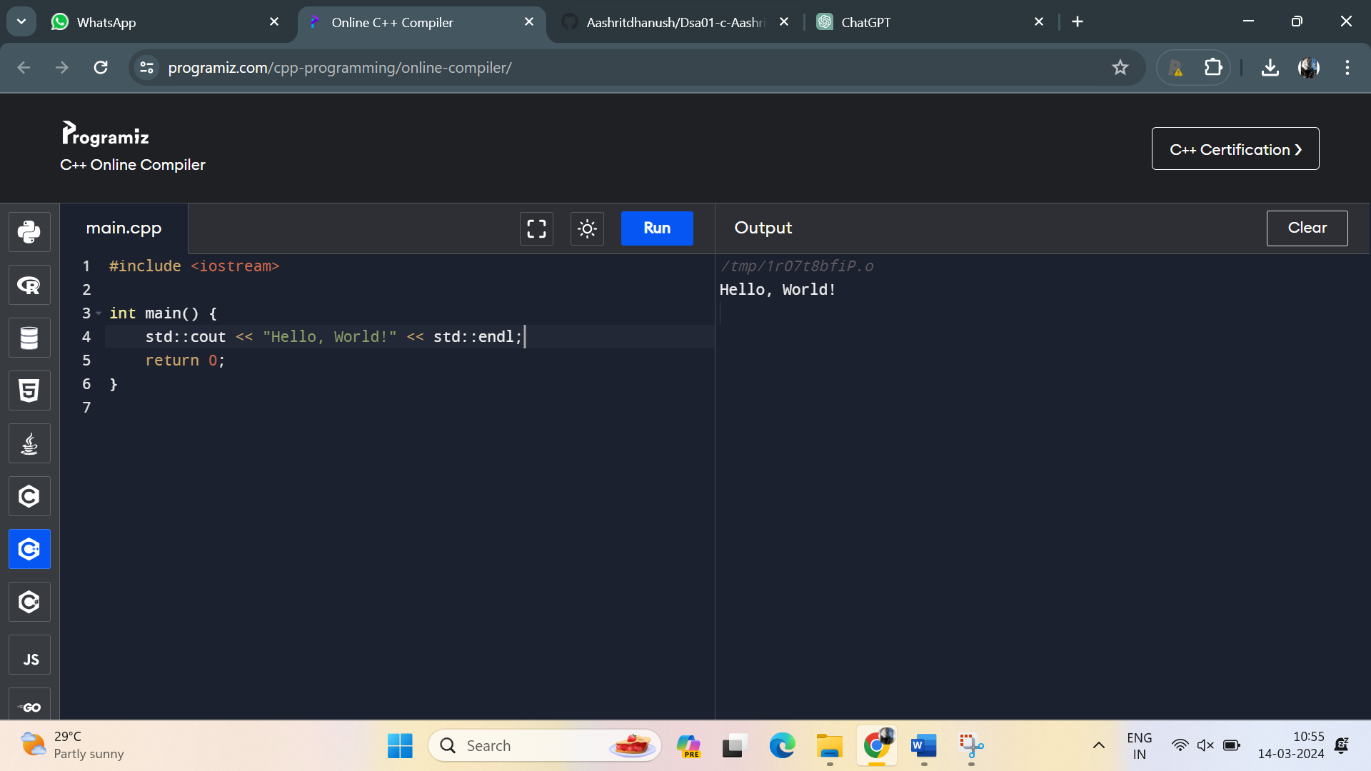

2. Create a C++ program with a function prototype for a function named **addNumbers** that takes two integers as parameters and returns their sum. Implement the function below the main function and use it to add two numbers.

Program:

#include <iostream>

// Function prototype

int addNumbers(int num1, int num2);

int main() {

int a = 5;

int b = 7;

int sum = addNumbers(a, b);

std::cout << "The sum of " << a << " and " << b << " is: " << sum << std::endl;

return 0;

}

int addNumbers(int num1, int num2) {

return num1 + num2;

}

Output:

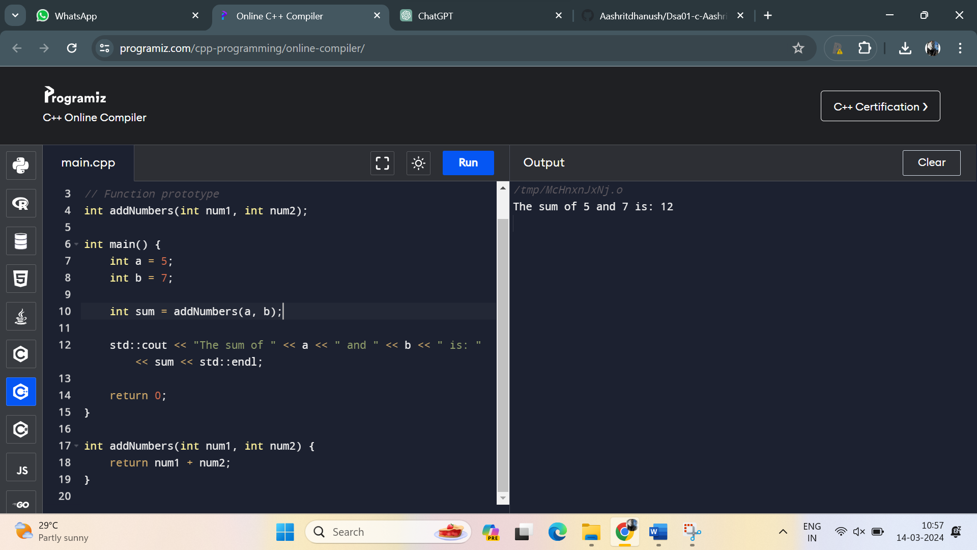

3. Write a C++ program that demonstrates call by reference by swapping the values of two variables.

Program:

#include <iostream>

void swap(int& a, int& b);

int main() {

int num1 = 5;

int num2 = 10;

std::cout << "Before swapping:" << std::endl;

std::cout << "num1 = " << num1 << ", num2 = " << num2 << std::endl;

swap(num1, num2);

std::cout << "After swapping:" << std::endl;

std::cout << "num1 = " << num1 << ", num2 = " << num2 << std::endl;

return 0;

}

void swap(int& a, int& b) {

int temp = a;

a = b;

b = temp;

}

Output:

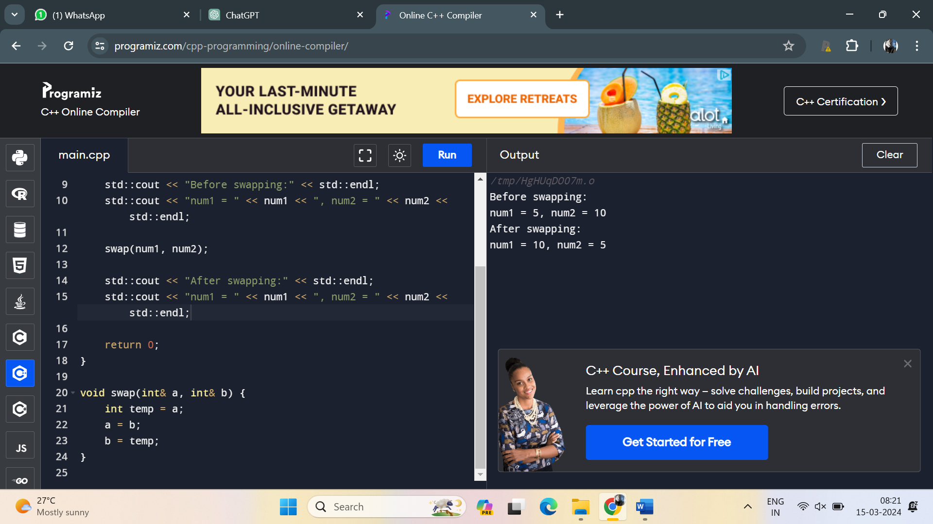

4. Develop a C++ program with a function that returns a reference to an integer variable and modifies its value. Use this function to update the value of a variable in the main function.

Program:

#include <iostream>

int& modifyValue(int& num);

int main() {

int num = 5;

std::cout << "Before modification: " << num << std::endl;

modifyValue(num) = 10;

std::cout << "After modification: " << num << std::endl;

return 0;

}

int& modifyValue(int& num) {

num++;

return num;

}

Output:

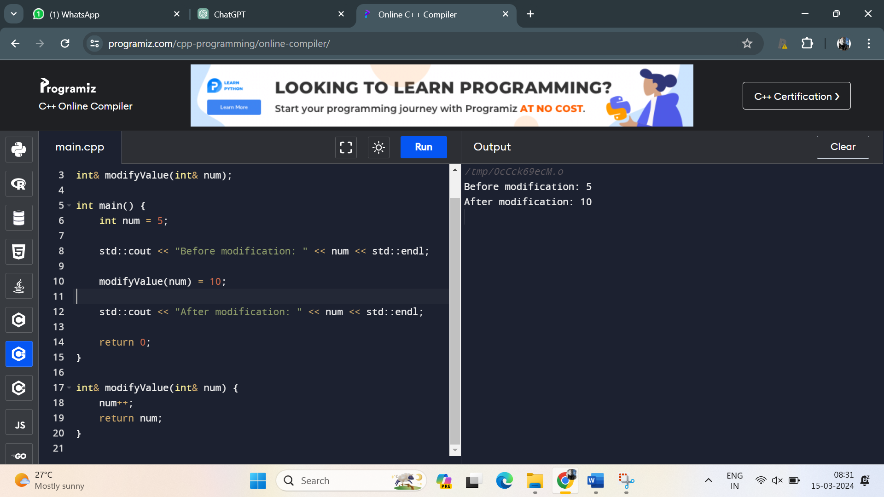

5. Implement an inline function named **square** that calculates the square of a number. Use this function to square a user-input integer.

Program:

#include <iostream>

inline int square(int num) {

return num * num;

}

int main() {

int input;

std::cout << "Enter an integer: ";

std::cin >> input;

int result = square(input);

std::cout << "Square of " << input << " is: " << result << std::endl;

return 0;

}

Output:

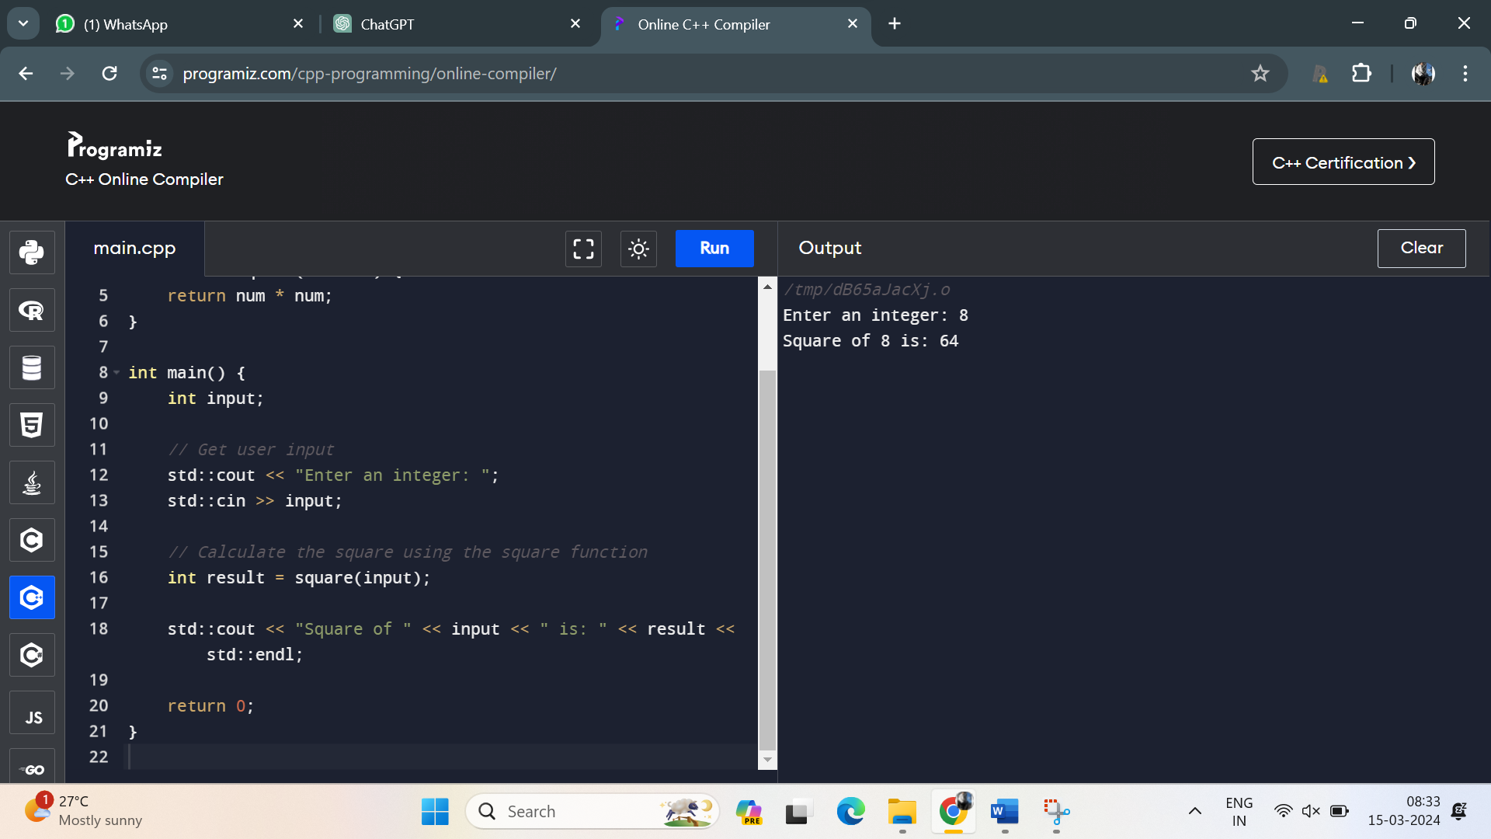

6. Write a C++ program that defines a function named **printMessage** with a default argument "Hello". Call this function without passing any argument

Program:

#include <iostream>

#include <string>

void printMessage(const std::string& message = "Hello");

int main() {

printMessage();

return 0;

}

void printMessage(const std::string& message) {

std::cout << message << std::endl;

}

Output:

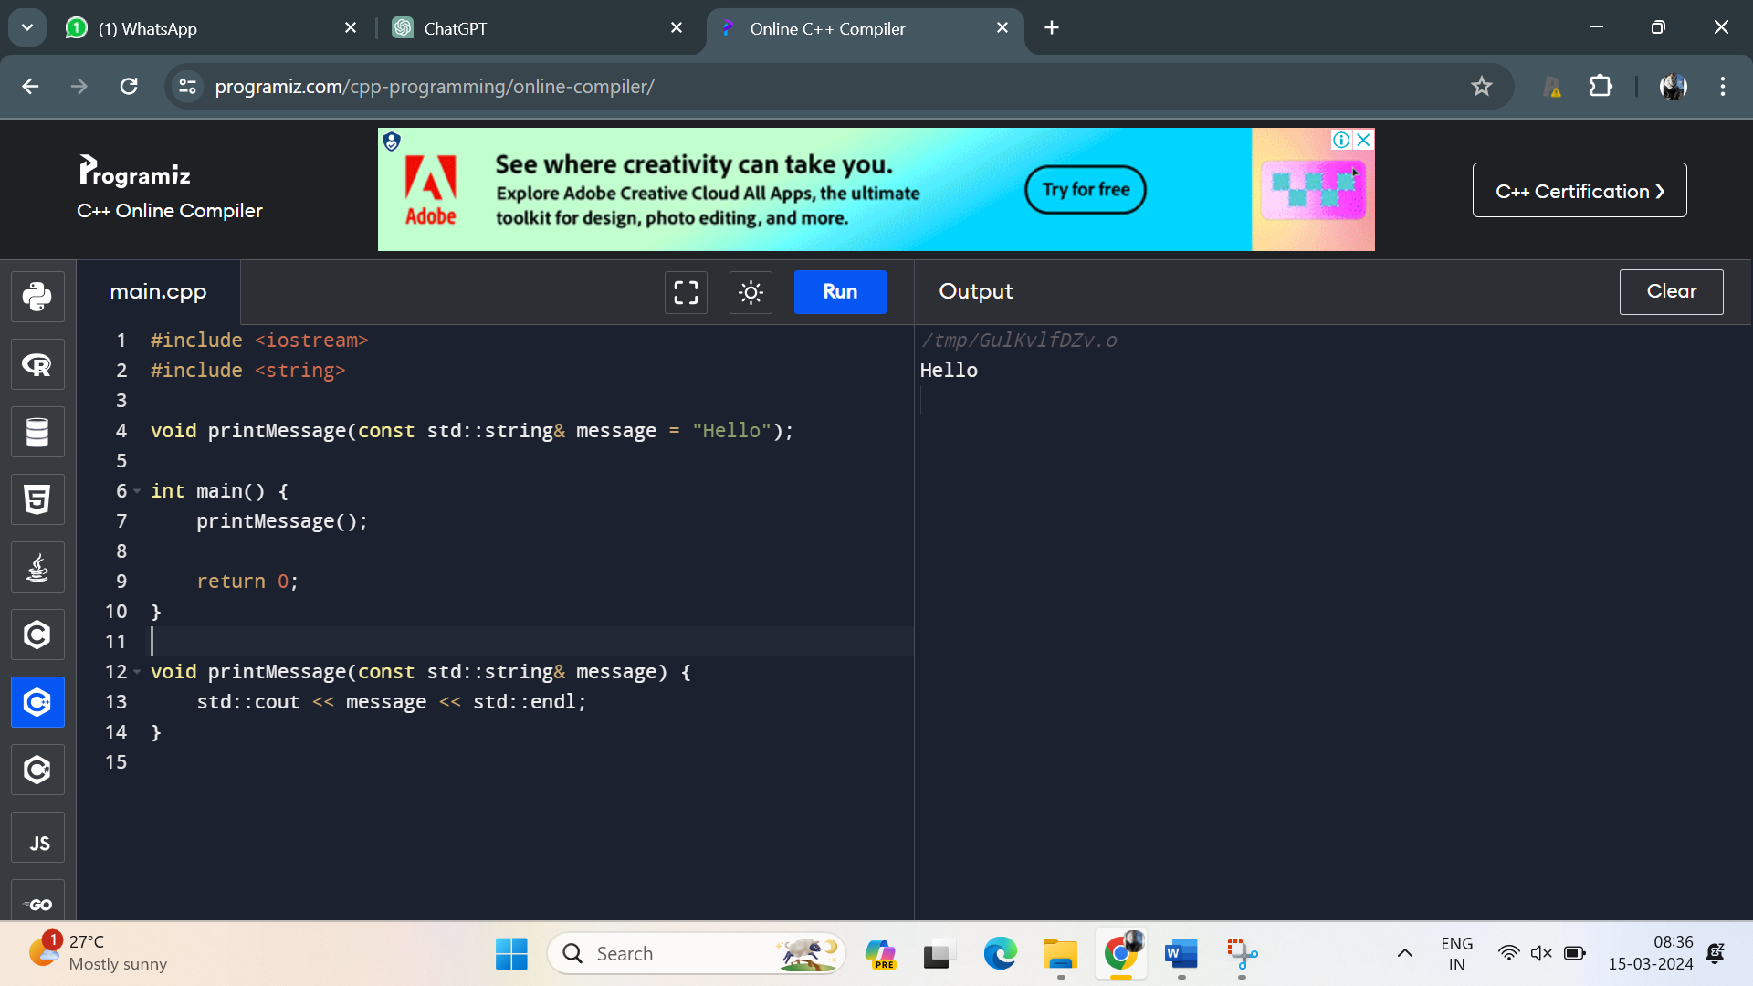

7. Create a C++ program with two overloaded functions named **area** - one to calculate the area of a rectangle (length * width) and another to calculate the area of a circle (π * radius^2). Use function overloading to determine which function to call based on the number of arguments.

Program:

#include <iostream>

#include <cmath>

const double PI = 3.14159265359;

double area(double length, double width);

double area(double radius);

int main() {

double length, width, radius;

std::cout << "Enter length and width of the rectangle: ";

std::cin >> length >> width;

std::cout << "Area of the rectangle: " << area(length, width) << std::endl;

std::cout << "Enter radius of the circle: ";

std::cin >> radius;

std::cout << "Area of the circle: " << area(radius) << std::endl;

return 0;

}

double area(double length, double width) {

return length * width;

}

double area(double radius) {

return PI * std::pow(radius, 2);

}

Output:

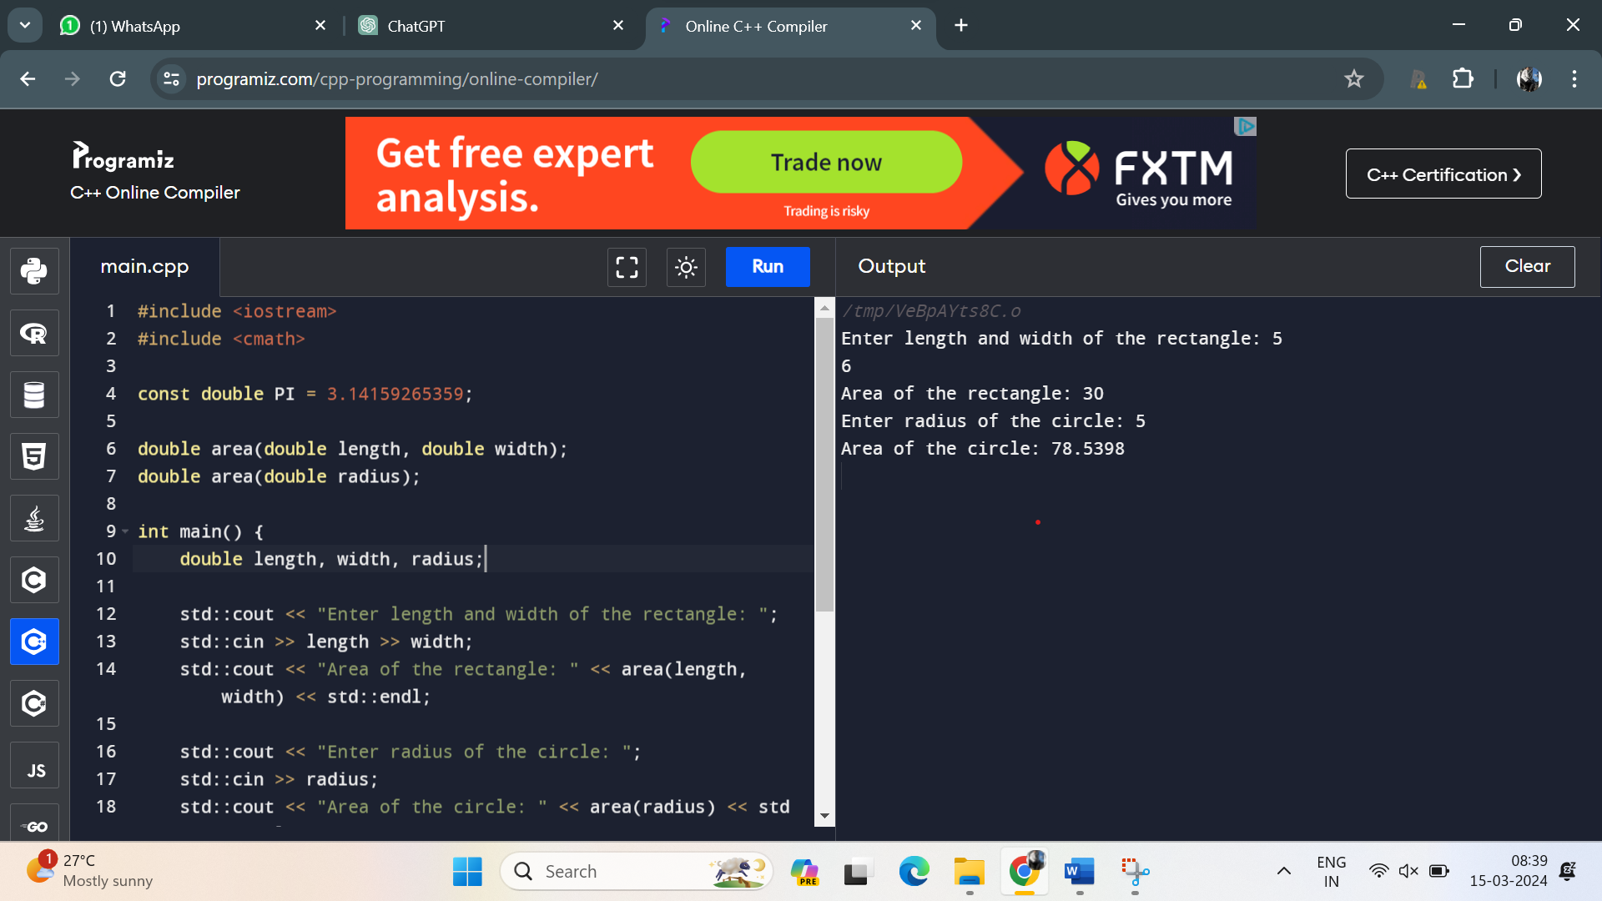

8. Define a C++ class named **Rectangle** with private member variables **length** and **width**. Implement public member functions to set and get the length and width of the rectangle.

Program:

#include <iostream>

class Rectangle {

private:

double length;

double width;

public:

Rectangle() {

length = 0.0;

width = 0.0;

}

void setLength(double len) {

length = len;

}

void setWidth(double wid) {

width = wid;

}

double getLength() const {

return length;

}

double getWidth() const {

return width;

}

};

int main() {

Rectangle rect;

rect.setLength(5.0);

rect.setWidth(3.0);

std::cout << "Length: " << rect.getLength() << std::endl;

std::cout << "Width: " << rect.getWidth() << std::endl;

return 0;

}

Output:

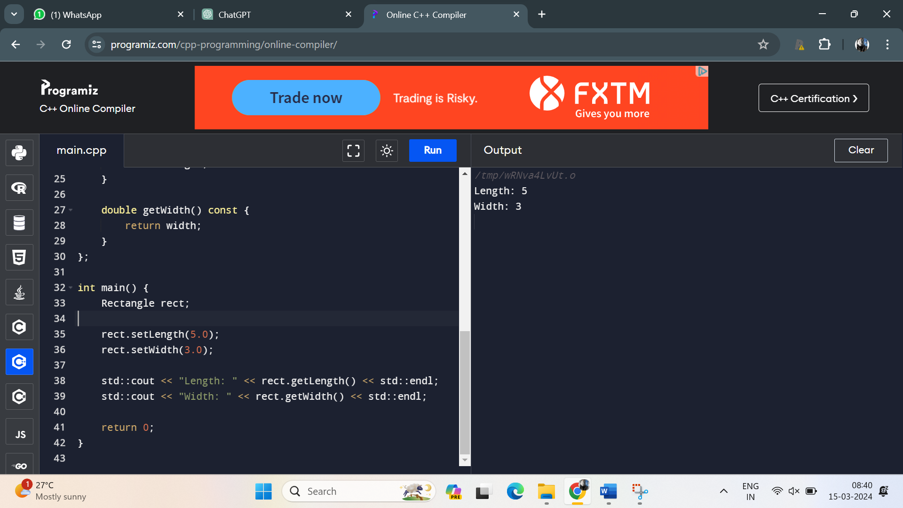

9. . Extend the **Rectangle** class to include an array of integers named **coordinates** to store the (x, y) coordinates of the rectangle. Implement member functions to set and get the coordinates.

Program:

#include <iostream>

class Rectangle {

private:

double length;

double width;

int coordinates[4];

public:

Rectangle() {

length = 0.0;

width = 0.0;

for (int i = 0; i < 4; ++i)

coordinates[i] = 0;

}

void setLength(double len) {

length = len;

}

void setWidth(double wid) {

width = wid;

}

double getLength() const {

return length;

}

double getWidth() const {

return width;

}

void setCoordinates(int x1, int y1, int x2, int y2) {

coordinates[0] = x1;

coordinates[1] = y1;

coordinates[2] = x2;

coordinates[3] = y2;

}

const int* getCoordinates() const {

return coordinates;

}

};

int main() {

Rectangle rect;

rect.setLength(5.0);

rect.setWidth(3.0);

rect.setCoordinates(1, 1, 6, 4);

std::cout << "Length: " << rect.getLength() << std::endl;

std::cout << "Width: " << rect.getWidth() << std::endl;

const int* coords = rect.getCoordinates();

std::cout << "Coordinates: ";

for (int i = 0; i < 4; ++i) {

std::cout << coords[i] << " ";

}

std::cout << std::endl;

return 0;

}

Output:

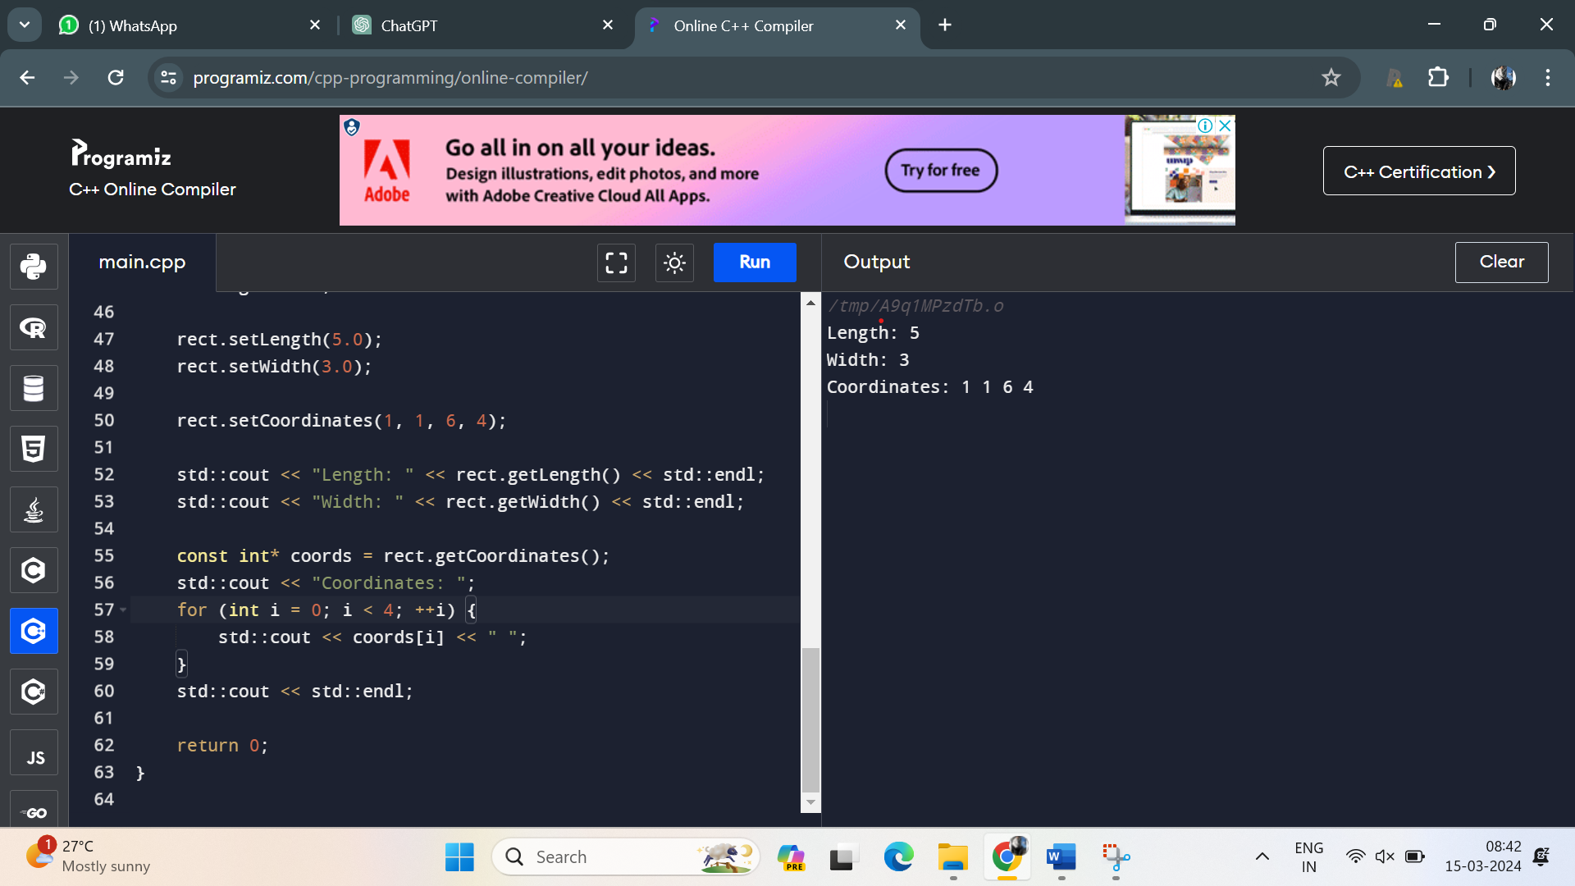

10. Add a static member function named **countRectangles** to the **Rectangle** class that keeps track of the total number of rectangle objects created. Display the count in the main function.

Program:

#include <iostream>

class Rectangle {

private:

double length;

double width;

int coordinates[4]; // Array to store (x, y) coordinates of the rectangle

static int totalRectangles; // Static member to keep track of total rectangles

public:

// Constructor

Rectangle() {

length = 0.0;

width = 0.0;

// Initialize coordinates to 0

for (int i = 0; i < 4; ++i)

coordinates[i] = 0;

// Increment total rectangles count when an object is created

totalRectangles++;

}

// Destructor

~Rectangle() {

// Decrement total rectangles count when an object is destroyed

totalRectangles--;

}

// Member functions to set the length and width

void setLength(double len) {

length = len;

}

void setWidth(double wid) {

width = wid;

}

// Member functions to get the length and width

double getLength() const {

return length;

}

double getWidth() const {

return width;

}

// Member functions to set and get coordinates

void setCoordinates(int x1, int y1, int x2, int y2) {

coordinates[0] = x1;

coordinates[1] = y1;

coordinates[2] = x2;

coordinates[3] = y2;

}

const int* getCoordinates() const {

return coordinates;

}

// Static member function to get the total number of rectangles

static int countRectangles() {

return totalRectangles;

}

};

// Definition of static member variable

int Rectangle::totalRectangles = 0;

int main() {

Rectangle rect1;

Rectangle rect2;

std::cout << "Total number of rectangles: " << Rectangle::countRectangles() << std::endl;

return 0;

}

Output:

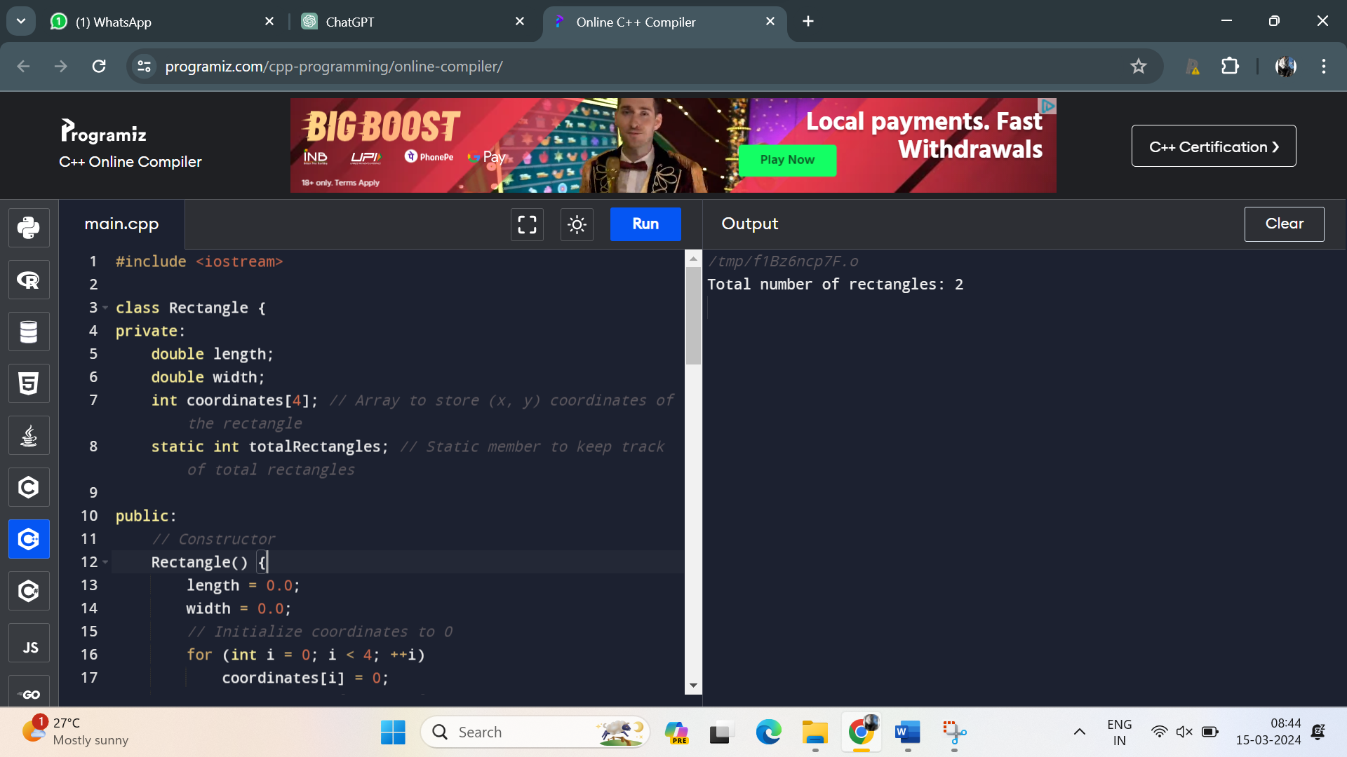

11. Write a C++ program that calculates the volume of a cube, rectangle, or cylinder based on user choice. Use function prototypes and function overloading to define separate functions for each shape's volume calculation.

Program:

#include <iostream>

#include <cmath>

// Function prototypes

double calculateVolume(double sideLength);

double calculateVolume(double length, double width, double height);

double calculateVolume(double radius, double height);

int main() {

int choice;

std::cout << "Choose the shape to calculate the volume:\n";

std::cout << "1. Cube\n";

std::cout << "2. Rectangular prism\n";

std::cout << "3. Cylinder\n";

std::cout << "Enter your choice (1, 2, or 3): ";

std::cin >> choice;

switch (choice) {

case 1: {

double sideLength;

std::cout << "Enter the side length of the cube: ";

std::cin >> sideLength;

std::cout << "Volume of the cube: " << calculateVolume(sideLength) << std::endl;

break;

}

case 2: {

double length, width, height;

std::cout << "Enter the length, width, and height of the rectangular prism: ";

std::cin >> length >> width >> height;

std::cout << "Volume of the rectangular prism: " << calculateVolume(length, width, height) << std::endl;

break;

}

case 3: {

double radius, height;

std::cout << "Enter the radius and height of the cylinder: ";

std::cin >> radius >> height;

std::cout << "Volume of the cylinder: " << calculateVolume(radius, height) << std::endl;

break;

}

default:

std::cout << "Invalid choice!" << std::endl;

break;

}

return 0;

}

// Function to calculate the volume of a cube

double calculateVolume(double sideLength) {

return std::pow(sideLength, 3);

}

// Function to calculate the volume of a rectangular prism

double calculateVolume(double length, double width, double height) {

return length * width * height;

}

// Function to calculate the volume of a cylinder

double calculateVolume(double radius, double height) {

return M_PI * std::pow(radius, 2) * height;

}

Output:

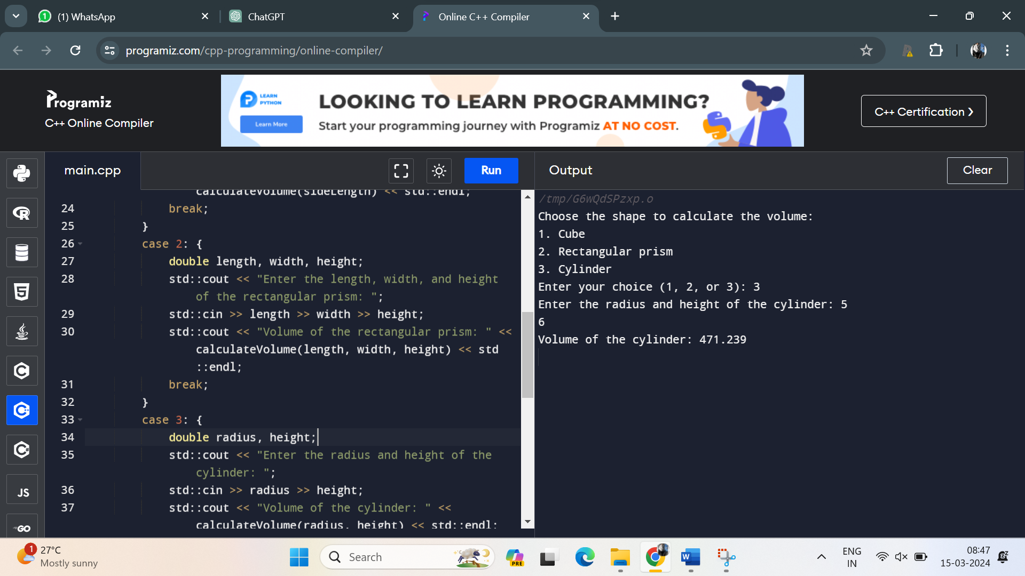

12. Define a class named **Student** with private member variables **name**, **id**, and an array **grades** to store the student's grades in three subjects. Implement member functions to set and get the student details and grades

Program:

#include <iostream>

#include <string>

class Student {

private:

std::string name;

int id;

int grades[3]; // Array to store grades for three subjects

public:

// Member function to set student details

void setDetails(const std::string& studentName, int studentId) {

name = studentName;

id = studentId;

}

// Member function to set grades for three subjects

void setGrades(int grade1, int grade2, int grade3) {

grades[0] = grade1;

grades[1] = grade2;

grades[2] = grade3;

}

// Member function to get student name

std::string getName() const {

return name;

}

// Member function to get student ID

int getId() const {

return id;

}

// Member function to get grades for three subjects

void getGrades(int& grade1, int& grade2, int& grade3) const {

grade1 = grades[0];

grade2 = grades[1];

grade3 = grades[2];

}

};

int main() {

Student student;

// Set student details

student.setDetails("John Doe", 123456);

// Set student grades

student.setGrades(85, 90, 78);

// Get and print student details

std::cout << "Student Name: " << student.getName() << std::endl;

std::cout << "Student ID: " << student.getId() << std::endl;

// Get and print student grades

int grade1, grade2, grade3;

student.getGrades(grade1, grade2, grade3);

std::cout << "Grades in three subjects: " << grade1 << ", " << grade2 << ", " << grade3 << std::endl;

return 0;

}

Output:

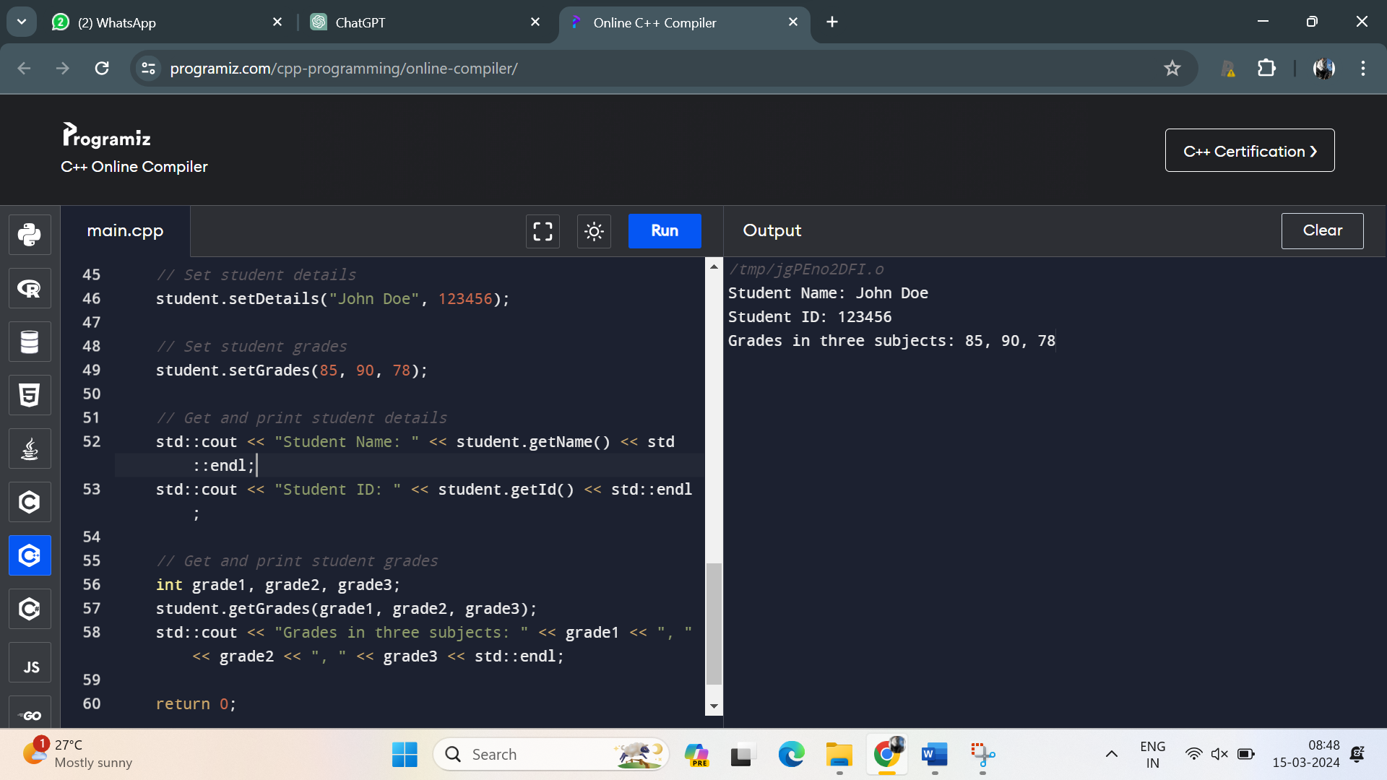

13. . Create a C++ program that defines an inline function named **calculateArea** to calculate the area of a rectangle. Provide default arguments for length and width parameters. Use this function to calculate the area of a rectangle with user-input dimensions.

Program:

#include <iostream>

// Inline function to calculate the area of a rectangle

inline double calculateArea(double length = 1.0, double width = 1.0) {

return length * width;

}

int main() {

double length, width;

// Input for rectangle dimensions

std::cout << "Enter the length of the rectangle: ";

std::cin >> length;

std::cout << "Enter the width of the rectangle: ";

std::cin >> width;

// Calculate the area using the calculateArea function

double area = calculateArea(length, width);

std::cout << "Area of the rectangle: " << area << std::endl;

return 0;

}

Output:

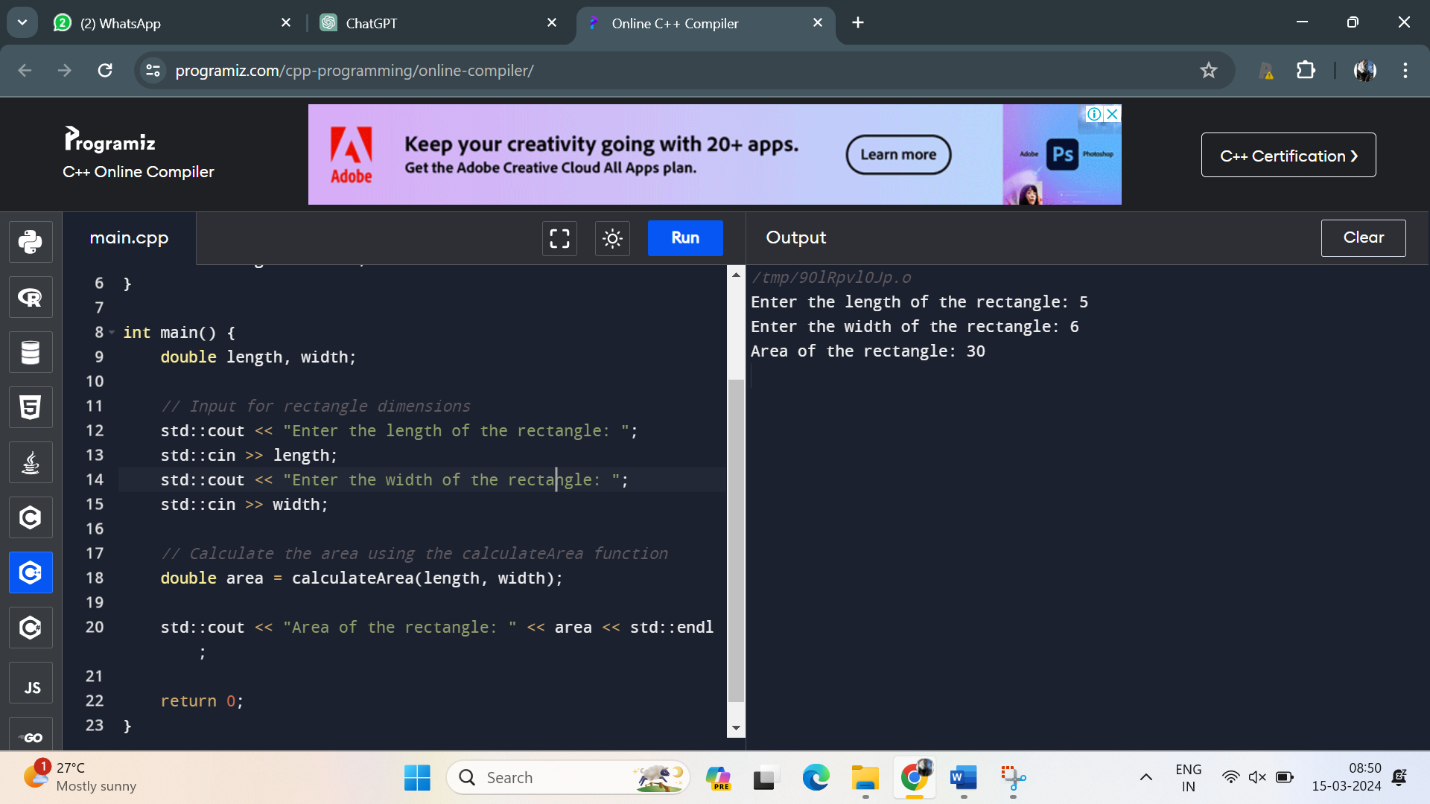

14. Define a class named **Employee** with private member variables **name** and **salary**. Implement a static member function to calculate the average salary of an array of **Employee** objects.

Program:

#include <iostream>

#include <string>

class Employee {

private:

std::string name;

double salary;

public:

// Constructor

Employee(const std::string& empName, double empSalary) : name(empName), salary(empSalary) {}

// Static member function to calculate the average salary of an array of Employee objects

static double calculateAverageSalary(Employee* employees, int numEmployees) {

if (numEmployees == 0)

return 0.0;

double totalSalary = 0.0;

for (int i = 0; i < numEmployees; ++i) {

totalSalary += employees[i].salary;

}

return totalSalary / numEmployees;

}

};

int main() {

// Create an array of Employee objects

const int numEmployees = 3;

Employee employees[numEmployees] = {

Employee("John", 50000.0),

Employee("Alice", 60000.0),

Employee("Bob", 70000.0)

};

// Calculate and display the average salary

double averageSalary = Employee::calculateAverageSalary(employees, numEmployees);

std::cout << "Average Salary: " << averageSalary << std::endl;

return 0;

}

Output:

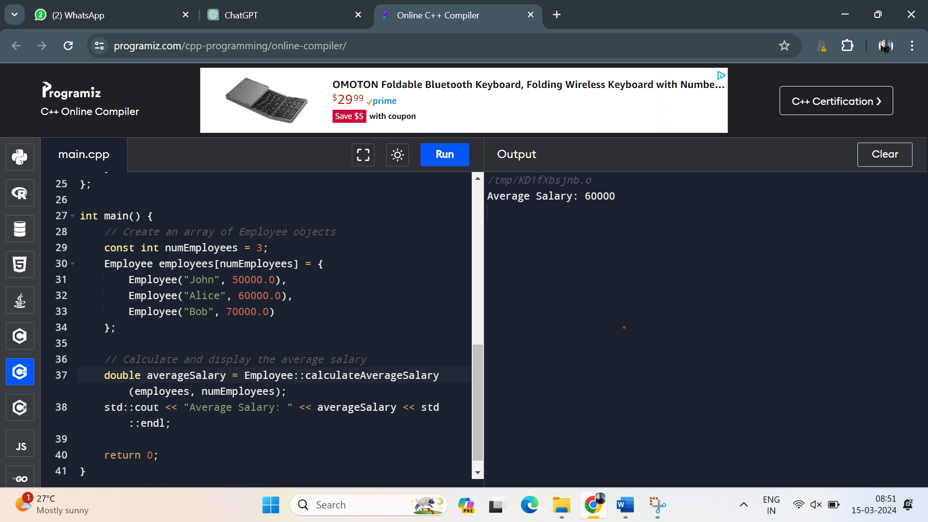

15. Define two classes, **Complex** and **Matrix**. Make **Matrix** a friend of **Complex**. Implement a function in **Matrix** class that multiplies a **Complex** number with a constant and returns the result by reference.

Program:

#include <iostream>

class Complex;

class Matrix {

public:

// Function prototype to multiply a Complex number with a constant

static Complex& multiplyWithConstant(const Complex& complexNum, double constant);

};

class Complex {

private:

double real;

double imag;

public:

// Constructor

Complex(double realVal, double imagVal) : real(realVal), imag(imagVal) {}

// Friend declaration to allow Matrix class access private members

friend class Matrix;

// Getter functions

double getReal() const { return real; }

double getImag() const { return imag; }

};

// Function definition to multiply a Complex number with a constant

Complex& Matrix::multiplyWithConstant(const Complex& complexNum, double constant) {

// Create a new Complex object with multiplied values

Complex* result = new Complex(complexNum.real * constant, complexNum.imag * constant);

return *result;

}

int main() {

// Create a Complex number

Complex complexNum(3.0, 4.0);

// Multiply the Complex number with a constant using the Matrix class function

Complex& result = Matrix::multiplyWithConstant(complexNum, 2.5);

// Display the result

std::cout << "Result: " << result.getReal() << " + " << result.getImag() << "i" << std::endl;

// Free dynamically allocated memory

delete &result;

return 0;

}

Output:

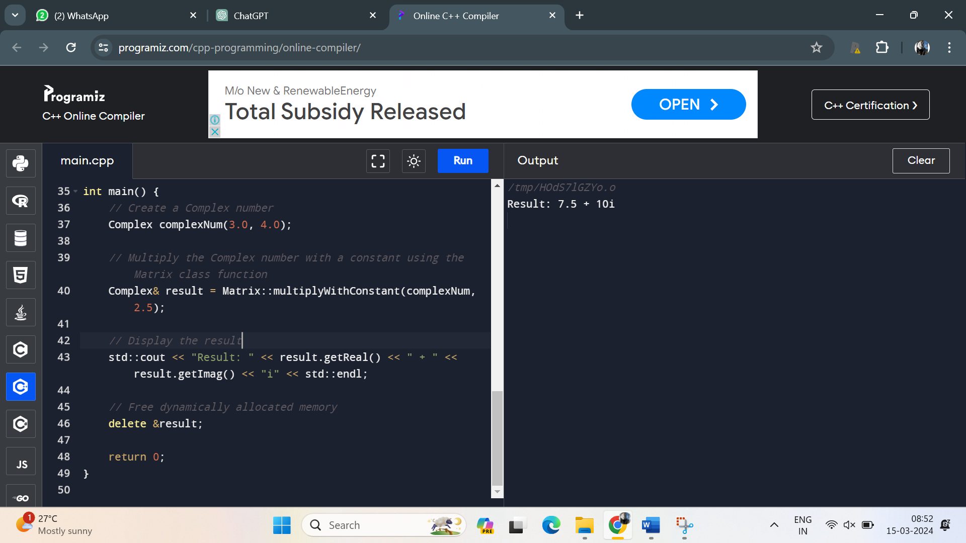

16. Write a C++ program that contains overloaded functions named **swap**. Define one version that swaps two integers and another version that swaps two arrays of integers. Implement these functions using call by reference.

Program:

#include <iostream>

// Function prototype to swap two integers

void swap(int& a, int& b);

// Function prototype to swap two arrays of integers

void swap(int arr1[], int arr2[], int size);

int main() {

// Testing swap for integers

int num1 = 5;

int num2 = 10;

std::cout << "Before swapping integers:" << std::endl;

std::cout << "num1 = " << num1 << ", num2 = " << num2 << std::endl;

// Call the swap function for integers

swap(num1, num2);

std::cout << "After swapping integers:" << std::endl;

std::cout << "num1 = " << num1 << ", num2 = " << num2 << std::endl;

// Testing swap for arrays

int arr1[] = {1, 2, 3};

int arr2[] = {4, 5, 6};

int size = sizeof(arr1) / sizeof(arr1[0]);

std::cout << "\nBefore swapping arrays:" << std::endl;

std::cout << "arr1: ";

for (int i = 0; i < size; ++i)

std::cout << arr1[i] << " ";

std::cout << std::endl;

std::cout << "arr2: ";

for (int i = 0; i < size; ++i)

std::cout << arr2[i] << " ";

std::cout << std::endl;

// Call the swap function for arrays

swap(arr1, arr2, size);

std::cout << "After swapping arrays:" << std::endl;

std::cout << "arr1: ";

for (int i = 0; i < size; ++i)

std::cout << arr1[i] << " ";

std::cout << std::endl;

std::cout << "arr2: ";

for (int i = 0; i < size; ++i)

std::cout << arr2[i] << " ";

std::cout << std::endl;

return 0;

}

// Function definition to swap two integers

void swap(int& a, int& b) {

int temp = a;

a = b;

b = temp;

}

// Function definition to swap two arrays of integers

void swap(int arr1[], int arr2[], int size) {

for (int i = 0; i < size; ++i) {

int temp = arr1[i];

arr1[i] = arr2[i];

arr2[i] = temp;

}

}

Output:

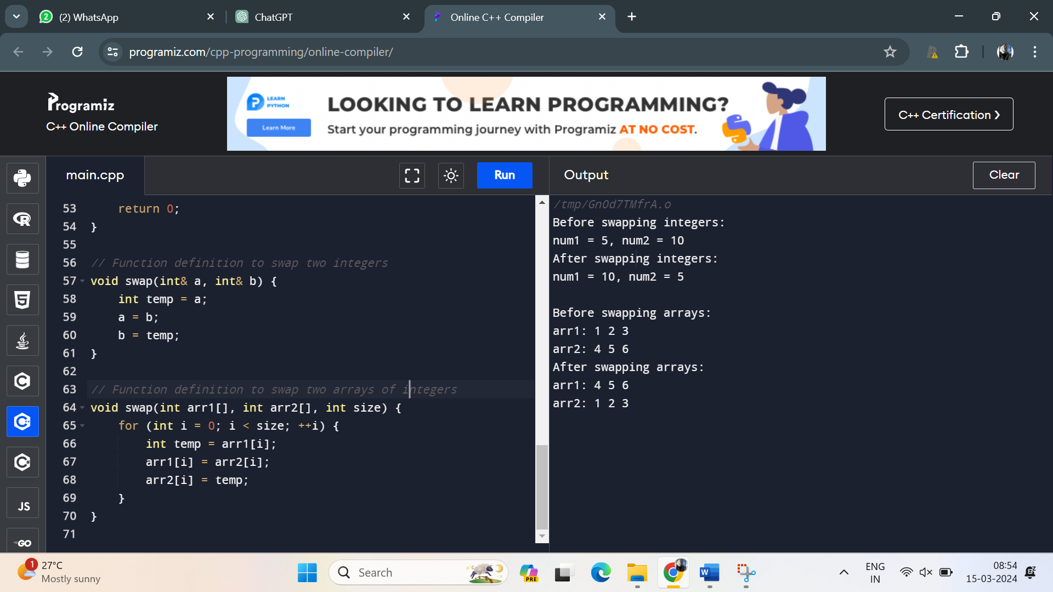

17. Define a class named **Circle** with private member variables **radius** and **area**. Implement member functions to set the radius, calculate the area, and display the circle's details.

Program:

#include <iostream>

class Circle {

private:

double radius;

double area;

public:

// Constructor

Circle() : radius(0.0), area(0.0) {}

// Member function to set the radius

void setRadius(double r) {

radius = r;

}

// Member function to calculate the area

void calculateArea() {

area = 3.14159 * radius * radius;

}

// Member function to display circle's details

void displayDetails() {

std::cout << "Circle details:" << std::endl;

std::cout << "Radius: " << radius << std::endl;

std::cout << "Area: " << area << std::endl;

}

};

int main() {

Circle circle;

// Set the radius

double r;

std::cout << "Enter the radius of the circle: ";

std::cin >> r;

circle.setRadius(r);

// Calculate the area

circle.calculateArea();

// Display circle's details

circle.displayDetails();

return 0;

}

Output:

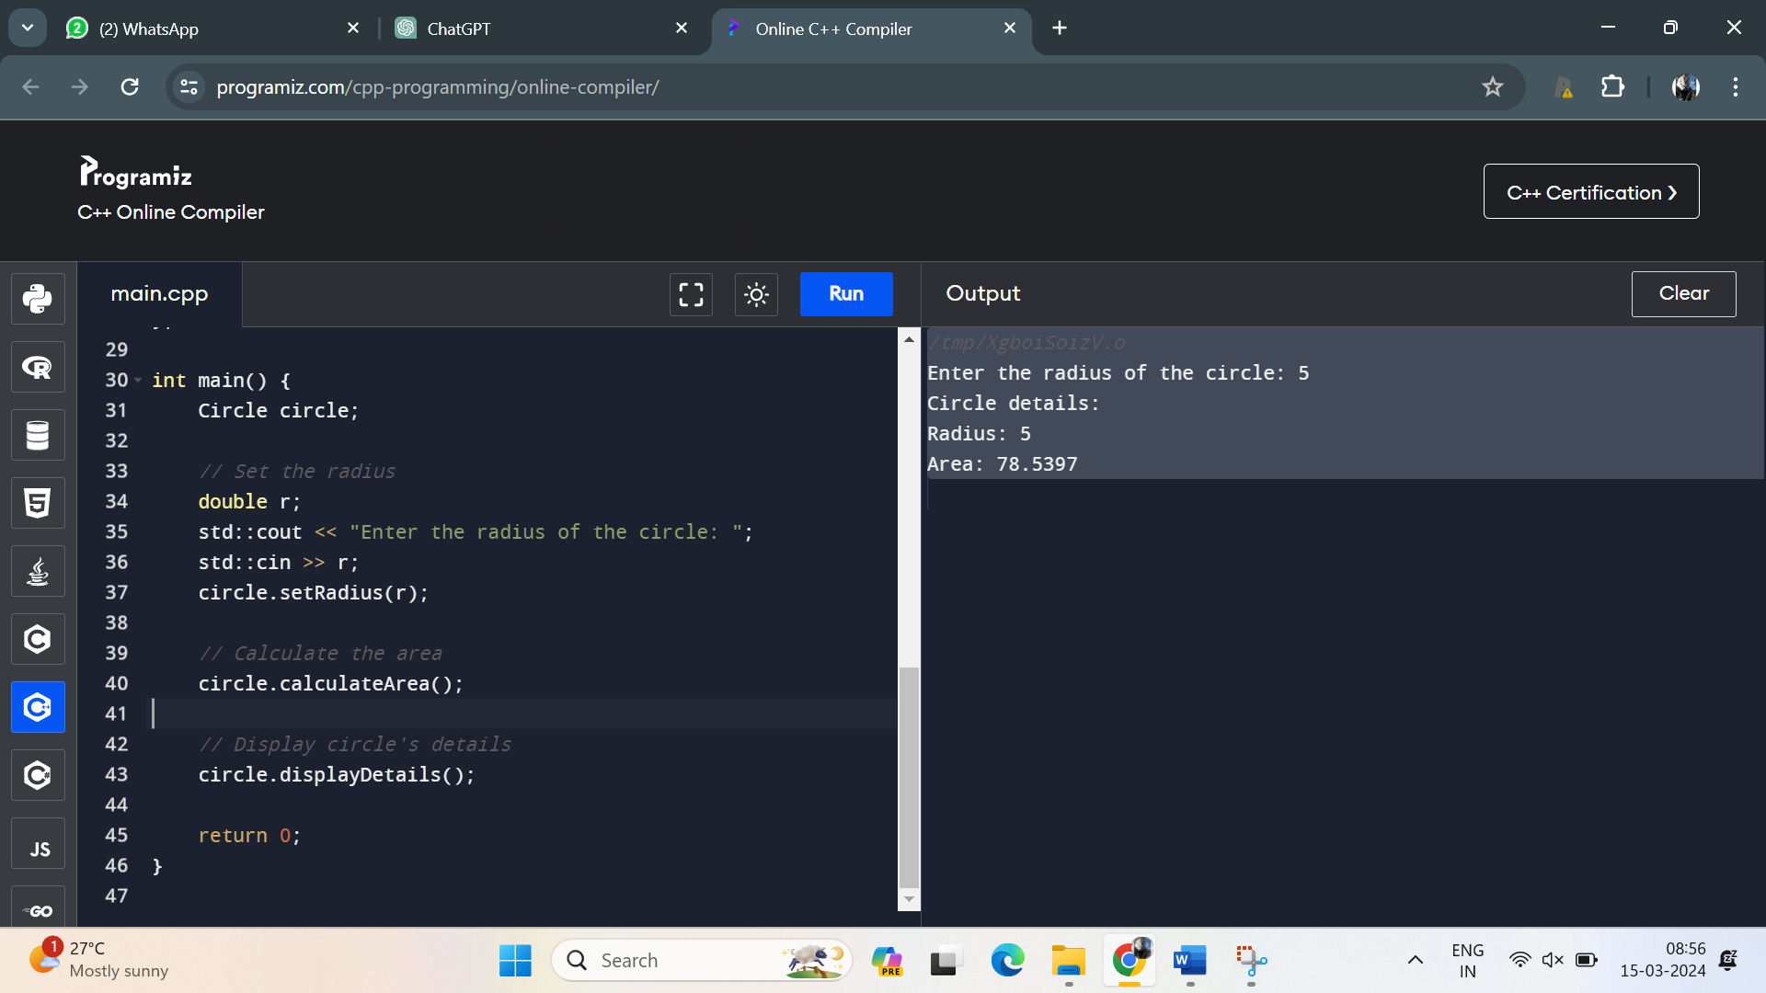

18. . Create a C++ program that defines a class named **Car** with private member variables **model**, **year**, and **price**. Implement an array of **Car** objects and provide default values for **year** and **price**.

Program:

#include <iostream>

#include <string>

class Car {

private:

std::string model;

int year;

double price;

public:

// Constructor with default values for year and price

Car(const std::string& carModel, int carYear = 2022, double carPrice = 0.0)

: model(carModel), year(carYear), price(carPrice) {}

// Function to display car details

void displayDetails() const {

std::cout << "Model: " << model << ", Year: " << year << ", Price: " << price << std::endl;

}

};

int main() {

// Create an array of Car objects

const int numCars = 3;

Car cars[numCars] = {

Car("Toyota Camry"),

Car("Honda Accord", 2021),

Car("Ford Mustang", 2019, 35000.0)

};

// Display details of each car

std::cout << "Car Details:" << std::endl;

for (int i = 0; i < numCars; ++i) {

std::cout << "Car " << i + 1 << ": ";

cars[i].displayDetails();

}

return 0;

}

Output:

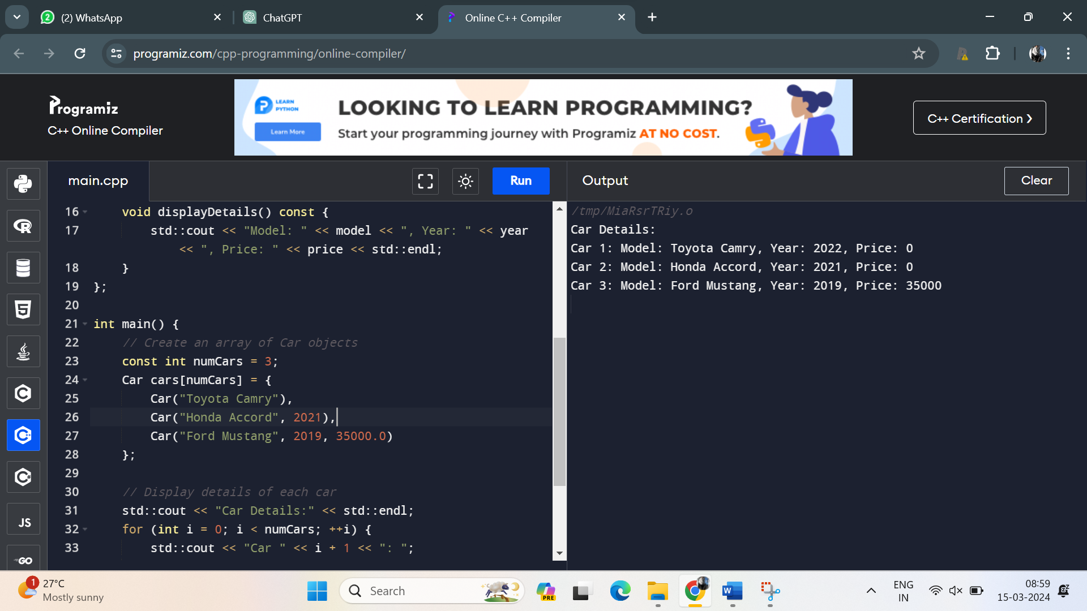

19. Define a C++ function named **largestElement** that returns a reference to the largest element in an array of integers. Use this function to find the largest element in a user-input array.

Program:

#include <iostream>

// Function prototype

int& largestElement(int arr[], int size);

int main() {

int size;

// Input for array size

std::cout << "Enter the size of the array: ";

std::cin >> size;

// Dynamically allocate memory for the array

int* arr = new int[size];

// Input for array elements

std::cout << "Enter the elements of the array:" << std::endl;

for (int i = 0; i < size; ++i) {

std::cout << "Element " << i + 1 << ": ";

std::cin >> arr[i];

}

// Find the largest element in the array using the largestElement function

int& largest = largestElement(arr, size);

// Display the largest element

std::cout << "The largest element in the array is: " << largest << std::endl;

// Deallocate memory

delete[] arr;

return 0;

}

// Function definition to find the largest element in an array

int& largestElement(int arr[], int size) {

int maxIndex = 0;

for (int i = 1; i < size; ++i) {

if (arr[i] > arr[maxIndex]) {

maxIndex = i;

}

}

return arr[maxIndex];

}

Output:

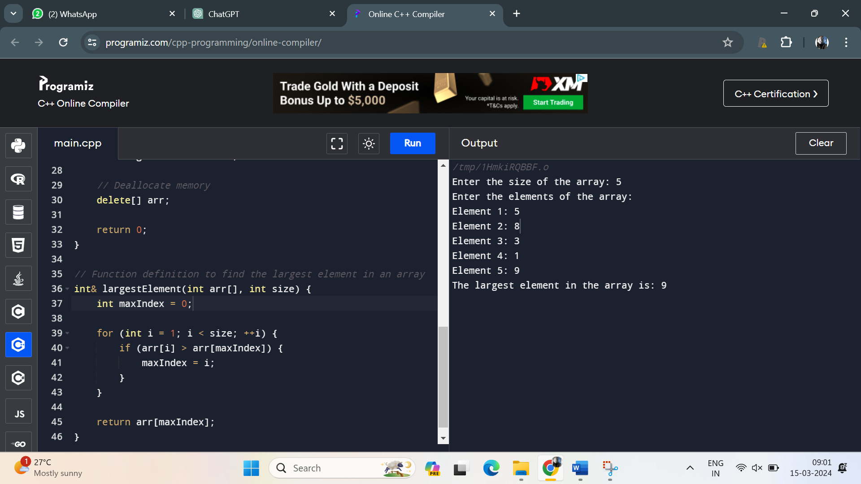

20. Write a C++ program with function prototypes for calculating the area and perimeter of a rectangle. Implement these functions with default arguments for length and width. Prompt the user to enter the length and width to calculate the area and perimeter.

Program:

#include <iostream>

// Function prototypes

double calculateArea(double length = 1.0, double width = 1.0);

double calculatePerimeter(double length = 1.0, double width = 1.0);

int main() {

double length, width;

// Input for length and width

std::cout << "Enter the length of the rectangle: ";

std::cin >> length;

std::cout << "Enter the width of the rectangle: ";

std::cin >> width;

// Calculate and display the area

double area = calculateArea(length, width);

std::cout << "Area of the rectangle: " << area << std::endl;

// Calculate and display the perimeter

double perimeter = calculatePerimeter(length, width);

std::cout << "Perimeter of the rectangle: " << perimeter << std::endl;

return 0;

}

// Function definition for calculating the area of a rectangle

double calculateArea(double length, double width) {

return length * width;

}

// Function definition for calculating the perimeter of a rectangle

double calculatePerimeter(double length, double width) {

return 2 * (length + width);

}

Output:

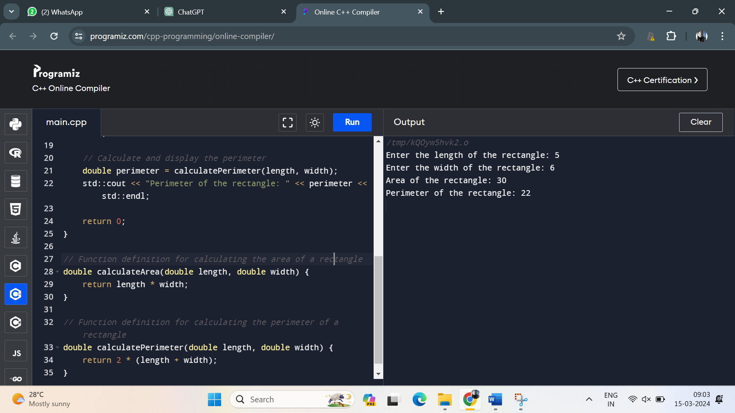

21. Write a C++ program with function prototypes for calculating the area and perimeter of a rectangle, circle, and triangle. Implement overloaded functions to handle each shape's calculations.

Program:

#include <iostream>

#include <cmath>

// Function prototypes for area and perimeter calculations

double calculateArea(double length, double width);

double calculatePerimeter(double length, double width);

double calculateArea(double radius);

double calculatePerimeter(double radius);

double calculateArea(double side1, double side2, double side3);

double calculatePerimeter(double side1, double side2, double side3);

int main() {

// Rectangle

double rectLength, rectWidth;

std::cout << "Enter the length of the rectangle: ";

std::cin >> rectLength;

std::cout << "Enter the width of the rectangle: ";

std::cin >> rectWidth;

std::cout << "Area of the rectangle: " << calculateArea(rectLength, rectWidth) << std::endl;

std::cout << "Perimeter of the rectangle: " << calculatePerimeter(rectLength, rectWidth) << std::endl;

// Circle

double circleRadius;

std::cout << "\nEnter the radius of the circle: ";

std::cin >> circleRadius;

std::cout << "Area of the circle: " << calculateArea(circleRadius) << std::endl;

std::cout << "Circumference of the circle: " << calculatePerimeter(circleRadius) << std::endl;

// Triangle

double side1, side2, side3;

std::cout << "\nEnter the lengths of the three sides of the triangle: ";

std::cin >> side1 >> side2 >> side3;

std::cout << "Area of the triangle: " << calculateArea(side1, side2, side3) << std::endl;

std::cout << "Perimeter of the triangle: " << calculatePerimeter(side1, side2, side3) << std::endl;

return 0;

}

// Function definitions for area and perimeter calculations of a rectangle

double calculateArea(double length, double width) {

return length * width;

}

double calculatePerimeter(double length, double width) {

return 2 * (length + width);

}

// Function definitions for area and perimeter calculations of a circle

double calculateArea(double radius) {

return M_PI * radius * radius;

}

double calculatePerimeter(double radius) {

return 2 * M_PI * radius;

}

// Function definitions for area and perimeter calculations of a triangle

double calculateArea(double side1, double side2, double side3) {

double s = (side1 + side2 + side3) / 2;

return sqrt(s * (s - side1) * (s - side2) * (s - side3));

}

double calculatePerimeter(double side1, double side2, double side3) {

return side1 + side2 + side3;

}

Output:

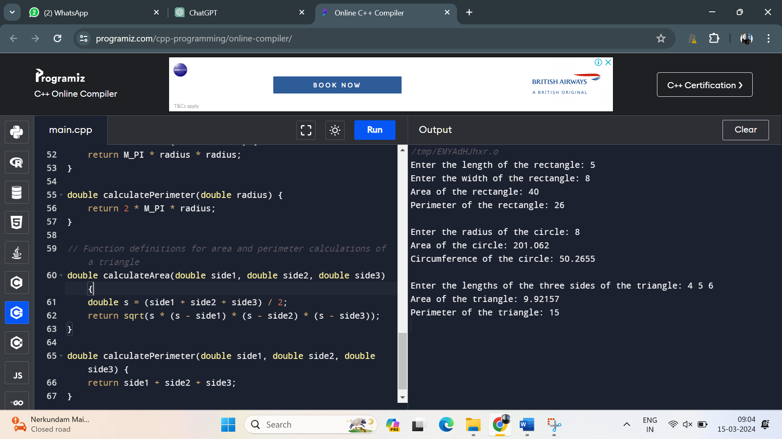

22. Define a class named **Complex** representing complex numbers with real and imaginary parts. Implement friend functions for addition, subtraction, multiplication, and division of complex numbers.

Program:

#include <iostream>

class Complex {

private:

double real;

double imag;

public:

// Constructor

Complex(double realPart = 0.0, double imagPart = 0.0) : real(realPart), imag(imagPart) {}

// Friend functions for arithmetic operations

friend Complex operator+(const Complex& c1, const Complex& c2);

friend Complex operator-(const Complex& c1, const Complex& c2);

friend Complex operator*(const Complex& c1, const Complex& c2);

friend Complex operator/(const Complex& c1, const Complex& c2);

// Function to display complex number

void display() const {

std::cout << real;

if (imag >= 0)

std::cout << " + " << imag << "i";

else

std::cout << " - " << -imag << "i";

std::cout << std::endl;

}

};

// Friend function definitions for arithmetic operations

Complex operator+(const Complex& c1, const Complex& c2) {

return Complex(c1.real + c2.real, c1.imag + c2.imag);

}

Complex operator-(const Complex& c1, const Complex& c2) {

return Complex(c1.real - c2.real, c1.imag - c2.imag);

}

Complex operator*(const Complex& c1, const Complex& c2) {

return Complex(c1.real * c2.real - c1.imag * c2.imag, c1.real * c2.imag + c1.imag * c2.real);

}

Complex operator/(const Complex& c1, const Complex& c2) {

double denominator = c2.real * c2.real + c2.imag * c2.imag;

if (denominator == 0) {

std::cerr << "Division by zero!" << std::endl;

return Complex();

}

return Complex((c1.real * c2.real + c1.imag * c2.imag) / denominator,

(c1.imag * c2.real - c1.real * c2.imag) / denominator);

}

int main() {

Complex c1(2.0, 3.0);

Complex c2(1.0, -1.0);

// Perform arithmetic operations

Complex addition = c1 + c2;

Complex subtraction = c1 - c2;

Complex multiplication = c1 * c2;

Complex division = c1 / c2;

// Display results

std::cout << "c1 + c2 = ";

addition.display();

std::cout << "c1 - c2 = ";

subtraction.display();

std::cout << "c1 * c2 = ";

multiplication.display();

std::cout << "c1 / c2 = ";

division.display();

return 0;

}

Output:

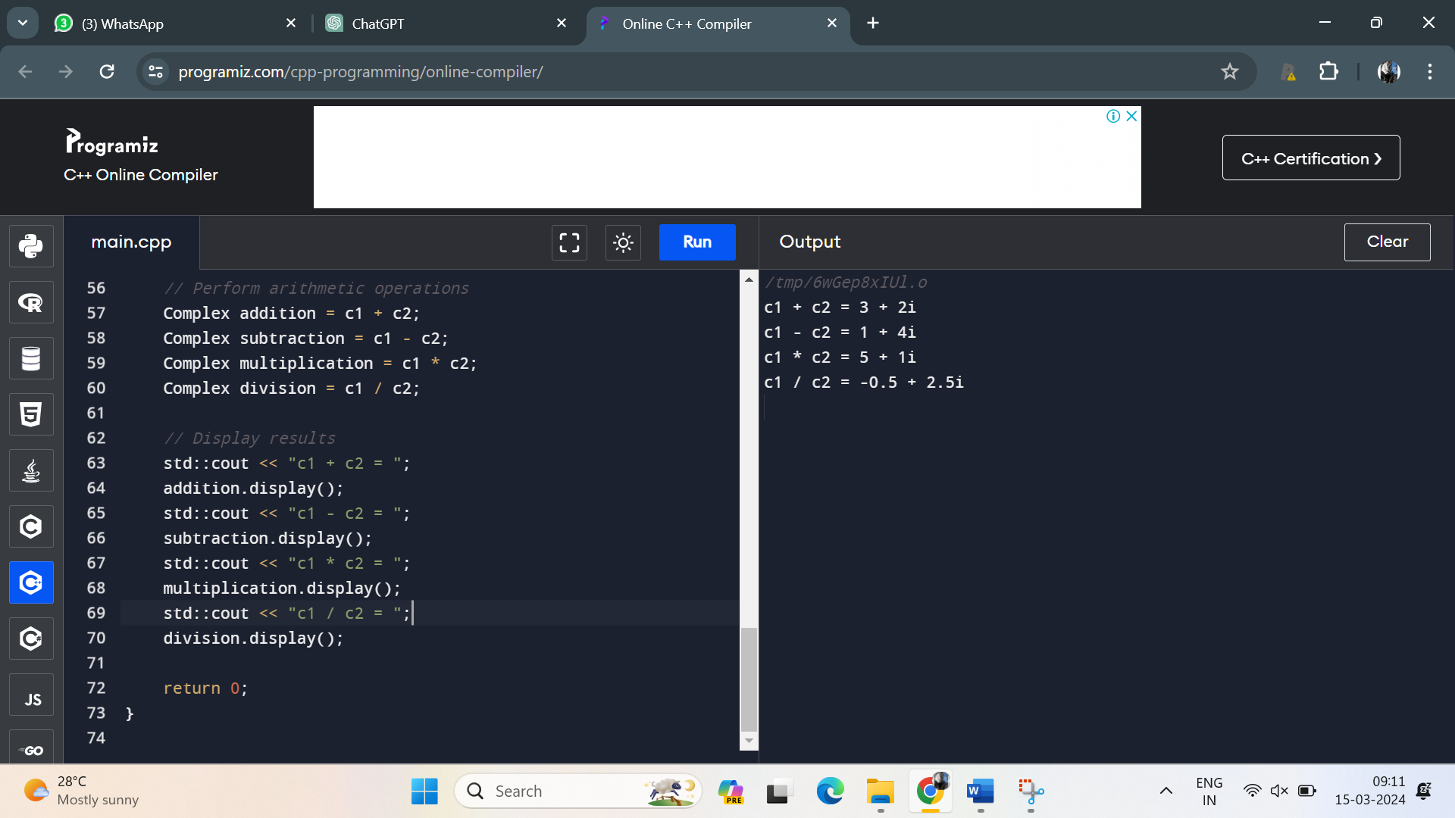

23. Create a C++ program that defines a class named **Matrix** to represent a 2D matrix. Implement operator overloading for matrix addition, subtraction, and multiplication. Use dynamic memory allocation for the matrix array within the class.

Program:

#include <iostream>

class Matrix {

private:

int rows;

int cols;

int** data;

public:

// Constructor

Matrix(int numRows, int numCols) : rows(numRows), cols(numCols) {

// Allocate memory for the matrix

data = new int*[rows];

for (int i = 0; i < rows; ++i) {

data[i] = new int[cols];

}

}

// Destructor

~Matrix() {

// Deallocate memory for the matrix

for (int i = 0; i < rows; ++i) {

delete[] data[i];

}

delete[] data;

}

// Overloaded assignment operator

Matrix& operator=(const Matrix& other) {

// Check for self-assignment

if (this != &other) {

// Deallocate existing memory

for (int i = 0; i < rows; ++i) {

delete[] data[i];

}

delete[] data;

// Copy dimensions

rows = other.rows;

cols = other.cols;

// Allocate new memory

data = new int*[rows];

for (int i = 0; i < rows; ++i) {

data[i] = new int[cols];

}

// Copy data

for (int i = 0; i < rows; ++i) {

for (int j = 0; j < cols; ++j) {

data[i][j] = other.data[i][j];

}

}

}

return *this;

}

// Overloaded addition operator

Matrix operator+(const Matrix& other) const {

if (rows != other.rows || cols != other.cols) {

std::cerr << "Matrix dimensions do not match for addition!" << std::endl;

return Matrix(0, 0);

}

Matrix result(rows, cols);

for (int i = 0; i < rows; ++i) {

for (int j = 0; j < cols; ++j) {

result.data[i][j] = data[i][j] + other.data[i][j];

}

}

return result;

}

// Overloaded subtraction operator

Matrix operator-(const Matrix& other) const {

if (rows != other.rows || cols != other.cols) {

std::cerr << "Matrix dimensions do not match for subtraction!" << std::endl;

return Matrix(0, 0);

}

Matrix result(rows, cols);

for (int i = 0; i < rows; ++i) {

for (int j = 0; j < cols; ++j) {

result.data[i][j] = data[i][j] - other.data[i][j];

}

}

return result;

}

// Overloaded multiplication operator

Matrix operator*(const Matrix& other) const {

if (cols != other.rows) {

std::cerr << "Matrix dimensions do not match for multiplication!" << std::endl;

return Matrix(0, 0);

}

Matrix result(rows, other.cols);

for (int i = 0; i < rows; ++i) {

for (int j = 0; j < other.cols; ++j) {

result.data[i][j] = 0;

for (int k = 0; k < cols; ++k) {

result.data[i][j] += data[i][k] * other.data[k][j];

}

}

}

return result;

}

// Function to display the matrix

void display() const {

for (int i = 0; i < rows; ++i) {

for (int j = 0; j < cols; ++j) {

std::cout << data[i][j] << " ";

}

std::cout << std::endl;

}

}

};

int main() {

// Create matrices

Matrix A(2, 3);

A.display();

std::cout << std::endl;

Matrix B(3, 2);

B.display();

std::cout << std::endl;

// Assign values to matrices

for (int i = 0; i < A.rows; ++i) {

for (int j = 0; j < A.cols; ++j) {

A.data[i][j] = i + j;

}

}

for (int i = 0; i < B.rows; ++i) {

for (int j = 0; j < B.cols; ++j) {

B.data[i][j] = i - j;

}

}

// Display matrices

std::cout << "Matrix A:" << std::endl;

A.display();

std::cout << std::endl;

std::cout << "Matrix B:" << std::endl;

B.display();

std::cout << std::endl;

// Perform matrix operations

Matrix C = A + B;

std::cout << "Matrix C = A + B:" << std::endl;

C.display();

std::cout << std::endl;

Matrix D = A - B;

std::cout << "Matrix D = A - B:" << std::endl;

D.display();

std::cout << std::endl;

Matrix E = A * B;

std::cout << "Matrix E = A * B:" << std::endl;

E.display();

std::cout << std::endl;

return 0;

}

24. Define a class named **Employee** with private member variables **id**, **name**, and **salary**. Implement a static member function to calculate the total salary of all employees. Include advanced member functions for employee details manipulation.

Program:

#include <iostream>

#include <vector>

class Employee {

private:

int id;

std::string name;

double salary;

static double totalSalary;

public:

// Constructor

Employee(int employeeId, const std::string& employeeName, double employeeSalary)

: id(employeeId), name(employeeName), salary(employeeSalary) {

totalSalary += salary; // Add salary to totalSalary when an employee is created

}

// Destructor

~Employee() {

totalSalary -= salary; // Subtract salary from totalSalary when an employee is destroyed

}

// Static member function to get the total salary of all employees

static double getTotalSalary() {

return totalSalary;

}

// Member functions for employee details manipulation

void setName(const std::string& newName) {

name = newName;

}

void setSalary(double newSalary) {

totalSalary -= salary; // Subtract old salary

salary = newSalary;

totalSalary += salary; // Add new salary

}

// Function to display employee details

void displayDetails() const {

std::cout << "ID: " << id << ", Name: " << name << ", Salary: " << salary << std::endl;

}

};

// Initialize static member variable

double Employee::totalSalary = 0.0;

int main() {

// Create some Employee objects

Employee emp1(1, "John", 50000);

Employee emp2(2, "Alice", 60000);

Employee emp3(3, "Bob", 70000);

// Display employee details

emp1.displayDetails();

emp2.displayDetails();

emp3.displayDetails();

// Display total salary of all employees

std::cout << "Total salary of all employees: " << Employee::getTotalSalary() << std::endl;

// Modify employee details

emp1.setSalary(55000);

emp2.setName("Emily");

// Display modified employee details

std::cout << "\nAfter modifications:" << std::endl;

emp1.displayDetails();

emp2.displayDetails();

emp3.displayDetails();

// Display updated total salary of all employees

std::cout << "Total salary of all employees: " << Employee::getTotalSalary() << std::endl;

return 0;

}

Output:

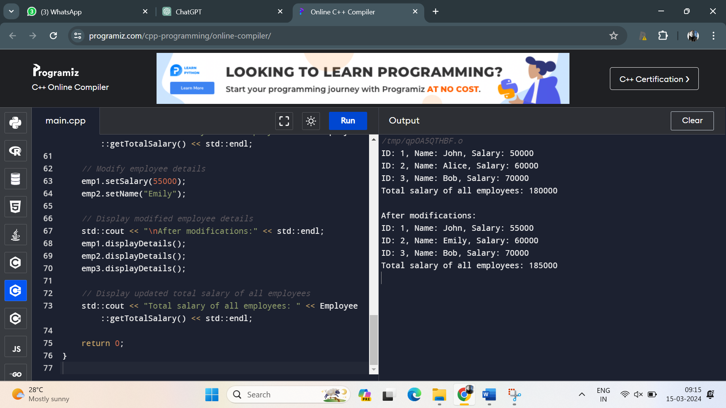

25. **.** Develop a C++ program that defines a class named **Vector3D** representing a 3D vector. Implement operator overloading for addition, subtraction, scalar multiplication, and cross product operations on arrays of **Vector3D** objects.

Program:

#include <iostream>

#include <vector>

class Vector3D {

private:

double x, y, z;

public:

// Constructor

Vector3D(double xVal = 0.0, double yVal = 0.0, double zVal = 0.0) : x(xVal), y(yVal), z(zVal) {}

// Overloaded addition operator

Vector3D operator+(const Vector3D& other) const {

return Vector3D(x + other.x, y + other.y, z + other.z);

}

// Overloaded subtraction operator

Vector3D operator-(const Vector3D& other) const {

return Vector3D(x - other.x, y - other.y, z - other.z);

}

// Overloaded scalar multiplication operator

Vector3D operator*(double scalar) const {

return Vector3D(x * scalar, y * scalar, z * scalar);

}

// Function to compute the cross product of two vectors

Vector3D crossProduct(const Vector3D& other) const {

return Vector3D(y * other.z - z * other.y, z * other.x - x * other.z, x * other.y - y * other.x);

}

// Function to display vector coordinates

void display() const {

std::cout << "(" << x << ", " << y << ", " << z << ")";

}

};

int main() {

// Create vectors

std::vector<Vector3D> vectors;

vectors.push_back(Vector3D(1.0, 2.0, 3.0));

vectors.push_back(Vector3D(4.0, 5.0, 6.0));

vectors.push_back(Vector3D(7.0, 8.0, 9.0));

// Display vectors

std::cout << "Vectors:" << std::endl;

for (const Vector3D& vec : vectors) {

vec.display();

std::cout << std::endl;

}

std::cout << std::endl;

// Compute and display addition of vectors

std::cout << "Addition of vectors:" << std::endl;

Vector3D sum;

for (const Vector3D& vec : vectors) {

sum = sum + vec;

}

sum.display();

std::cout << std::endl << std::endl;

// Compute and display subtraction of vectors

std::cout << "Subtraction of vectors:" << std::endl;

Vector3D diff = vectors[0];

for (size_t i = 1; i < vectors.size(); ++i) {

diff = diff - vectors[i];

}

diff.display();

std::cout << std::endl << std::endl;

// Compute and display scalar multiplication of vectors

double scalar = 2.0;

std::cout << "Scalar multiplication of vectors by " << scalar << ":" << std::endl;

for (const Vector3D& vec : vectors) {

(vec * scalar).display();

std::cout << std::endl;

}

std::cout << std::endl;

// Compute and display cross product of vectors

std::cout << "Cross product of vectors:" << std::endl;

vectors[0].crossProduct(vectors[1]).display();

std::cout << std::endl;

return 0;

}

Output:

